Two Day Jewel Box Class

This is a two day class using Jewel Box Templates. It is a design, piece and quilt project that can be completed within the two days.
Students will design their quilt using smaller templates, paper and coloured pencils and then transfer the design to fabric using the Jewel Box templates. They will complete the quilt up to binding stage.
Basic patchwork methods and techniques to be covered will include how to transfer ideas to fabric using graphic angles, strip sets, value, mixing stripes, floral/pattern and plain fabrics at the design stage. We will work on accurate methods and sequential piecing, finally there will tips on easy and quick quilting including how to ‘bag’ or double binding.
The basic quilt measures approx 45”x 47”

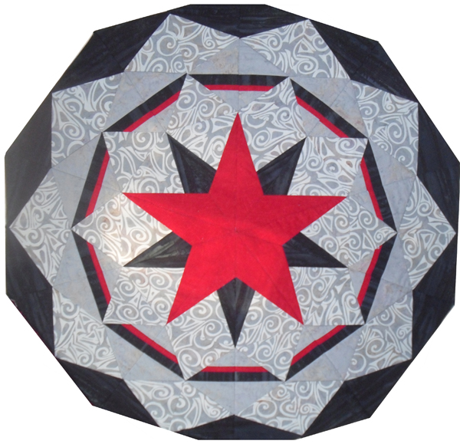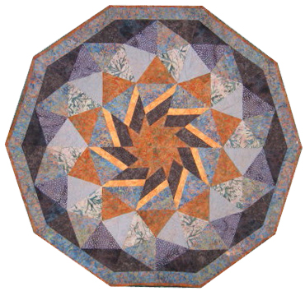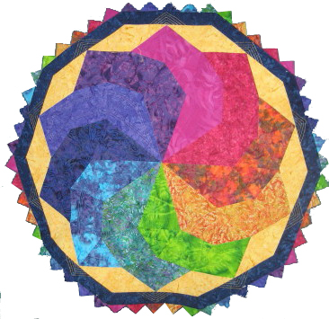
Betsy Ross Moroccan Tile The Swirl

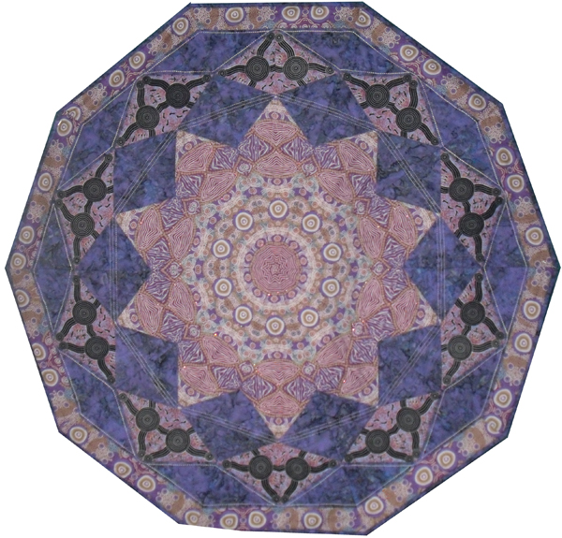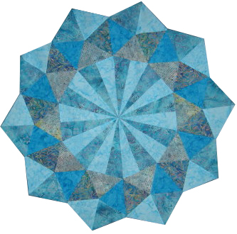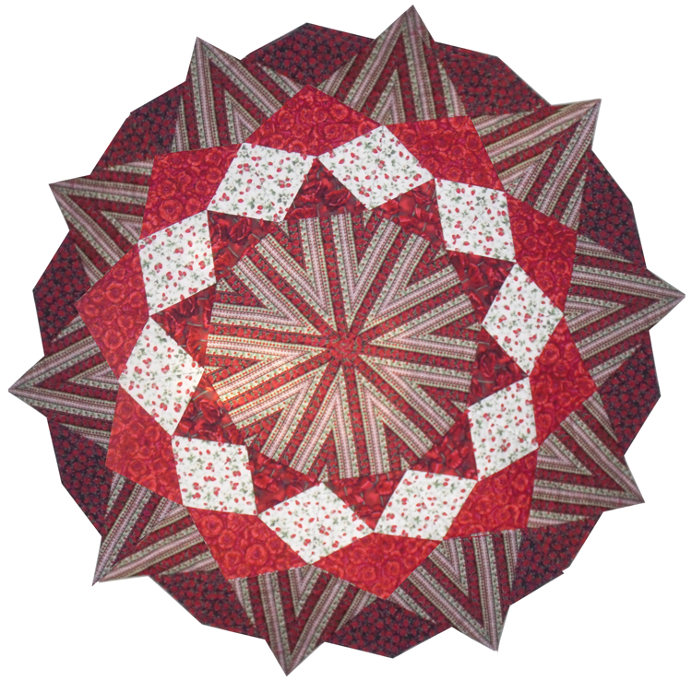
Amethyst Aquamarine Ruby

Contact: Kerry Glen
Kerry@tulis.co.nz
Mob +64 21 774 972

