Titivate your Stash
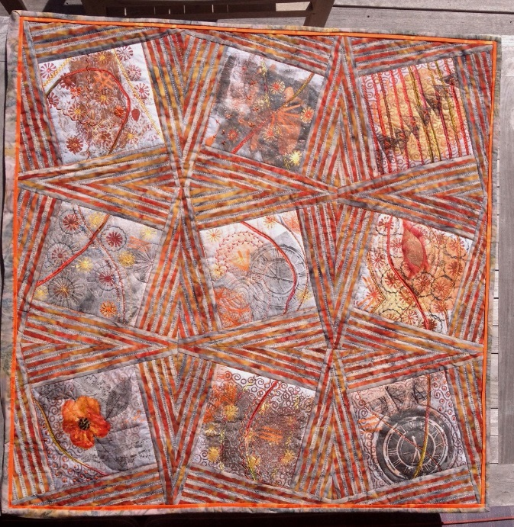

This class is designed to rejuvenate the fabrics in your stash and create original fabrics for your own individual work.
We will be creating stamps from everyday items, monoprinting with Gelli Plates and using foil to add sparkle.
We are having a “play day” and each student will have fabrics to take home they can use in their pieced quilts, art quilts and any form of textile creation.
The class is suitable for all levels of creative minds.

