One Day Gem Class

What is your favourite gem stone? This one day class uses the Jewel Box templates; the class will each piece and quilt this fun style of quilt. It is suitable for the beginner and intermediate quilter Basic patchwork methods and techniques covered will include options for quilting and binding. We will construct The Swirl below with a straight border and binding. They will be able to complete the quilt up to binding stage.

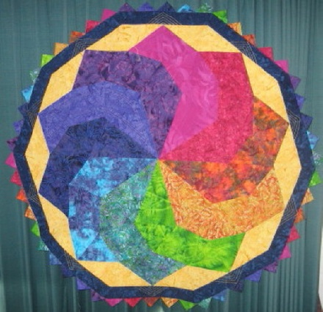

The Swirl

Examples of other Jewel Box Quilts.

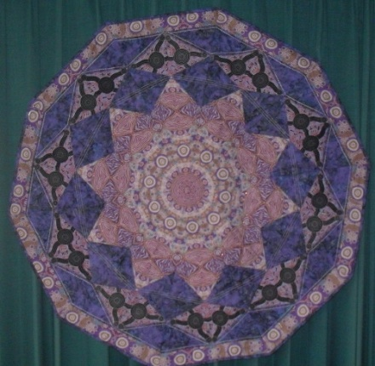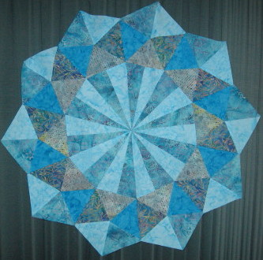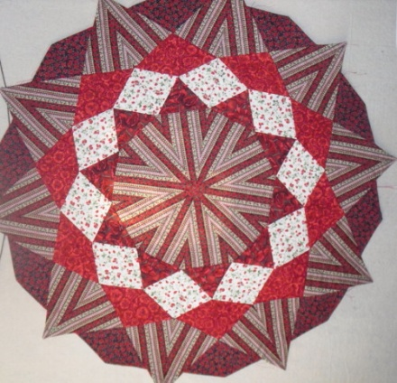

Contact Details: Kerry Glen
Email kerry@tulis.co.nz
+64 21 774 972

