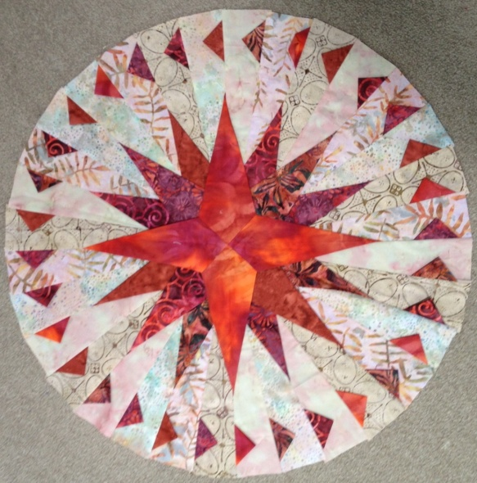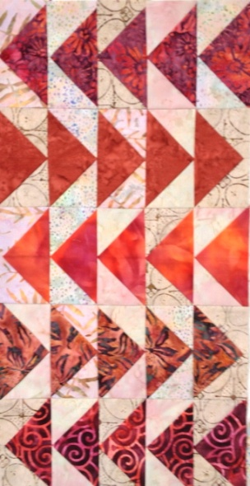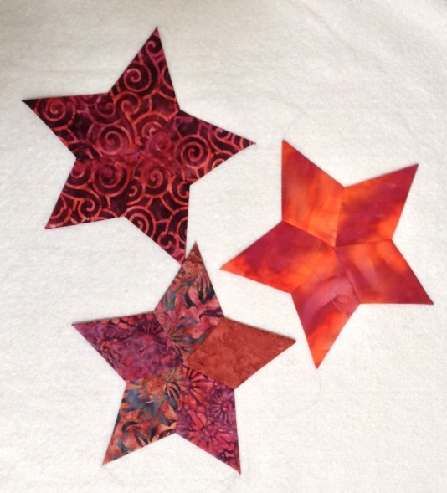
Four Folded Favourites One Day Class
This class is a technique class where folded and dimensional blocks are made. The students will complete 3 small projects.
- Compass with Prairie points.
- Folded Flying Geese
- Folded Stars.
Requirements:
5 Dark Fat Quarters
4 Light Fat Quarters for background.

Sewing Machine with ¼” foot and manual
Neutral fine thread for piecing. If using cream background please use cream thread.
Basic sewing kit. Pins, spare machine needles, sharp scissors,
Darning needle.
Quick n pick
Rotary Cutter and mat.
Quilting ruler
Glasses if you need them for reading.

Phillips Fiber Mariners Compass templates
Jewel Box Gemstar template
Please bring these if you have them I will have some available for use on the day.
Kerry Glen
Contact email :Kerry@tulis.co.nz
Ph 021 774 972 NZ
+ 6421 774 972 Intl

