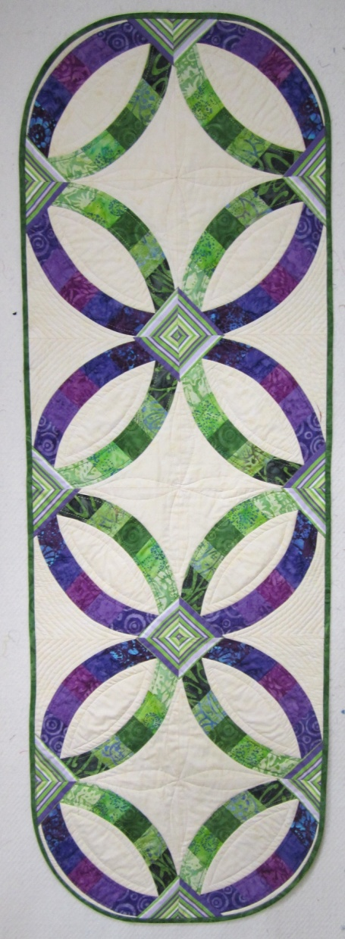
Double Wedding Ring Runner

This class uses the Simple Curve tool to create the simplest Wedding ring .The blocks are designed using the Simple Bands Pattern by Cheryl Phillips and Jelly roll strips with a stripe cornerstone.
Techniques covered will be, working with Curves and Strips, I will also talk about the number of ways you can use the Simple Curve tool to create your own quilts. This is a class aimed at the beginner and intermediate quilter and basic patchwork and quilting methods will be covered.

