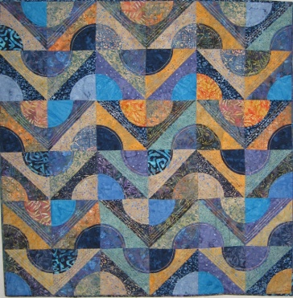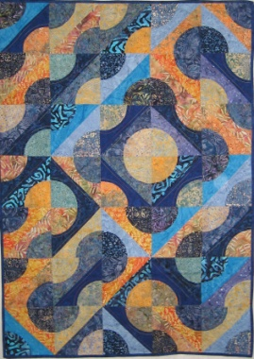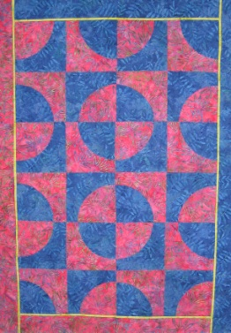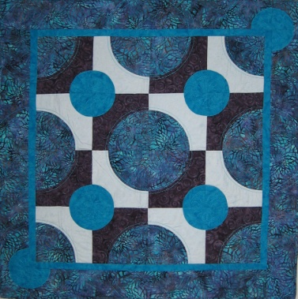

Drunkards Path Stepping Beyond Workshop.
2 Day Class
The traditional Drunkard’s Path is only the starting point for this fun piecing class. We will cover and construct 3 block techniques with the student choosing one and then constructing a small quilt. This class works with accurate cutting and piecing circles and then by playing with the layouts we create individual quilts. It suits the beginner through to the experienced quilters and is a fun way to become confident with working on circular shapes.

1 Day Class
As above, this is a technique class, 4 sets of blocks will be constructed by students. Some cutting prior to class will be required. They will have 4 samples on which to base future quilts on.
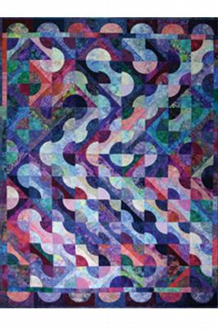
Reproduced with permission from Cheryl Phillips. Phillips Fiber Art
Contact: Kerry Glen
Kerry@tulis.co.nz
Ph. +64 21 774 972

